Final Assessment Report Template: Big Data Analytics and Visualization
DO NOT PUT YOUR NAME OR ANY OTHER IDENTIFIER ON THIS DOCUMENT

Section 1 — Data analysis
- Investigate given data and state the three business or research questions that you would like to answer through your analysis and justify why they are interesting (300 words maximum)
Research questions and justification
The dataset contains 244 observations from Bejaia and Sidi-Bel Abbes during June–September 2012, with meteorological measurements, FWI-system variables and a recorded class label (Abid, 2019). Its Classes variable is an FWI/FFMC-derived designation described in the original dataset context (Abid and Izeboudjen, 2020), not independently observed wildfire incidence. Accordingly, the questions address label reproduction, adjusted association and descriptive comparison—not real-wildfire prediction, causal effects or future forecasting.
RQ1: How accurately can Temperature, relative humidity, wind speed and rainfall reproduce the dataset’s FWI/FFMC-derived class designation, and which of these meteorological variables contribute most to that classification?
This question is useful because it evaluates whether directly measured weather variables can reproduce the recorded designation and identifies which variables contribute most within the classification approach. It is answerable because all four predictors and the binary designation are recorded for each observation.
RQ2: Does the association between region and the recorded FWI/FFMC-derived class designation persist after adjustment for the measured meteorological variables?
This question examines whether an observed regional association remains after accounting for measured weather differences. It is answerable because region, class designation and the required meteorological covariates are available, while the wording appropriately avoids causal interpretation.
RQ3: How do FWI values and the proportion of observations assigned the fire class vary across Bejaia and Sidi-Bel Abbes during June–September 2012?
This question provides a descriptive regional and temporal comparison. It is answerable because the dataset contains date, region, FWI and class designation for both locations across the four-month study period.
Together, the questions cover label reproduction, adjusted association and descriptive temporal comparison while remaining aligned with the dataset’s scope.
- Describe how you explored/visualized the data, why you did it that way, and what conclusions you drew about it (300 words maximum)
Exploratory data analysis
I explored Temperature, relative humidity, wind speed, rainfall and FWI through summary statistics and distribution plots, then examined weather variables by recorded class, region-by-month class proportions, and weekly mean FWI. The recorded classes comprised 138 fire and 106 not fire observations. Pooled and within-region Mann–Whitney comparisons with Cliff’s δ and Holm adjustment were used because rainfall was zero-heavy and several distributions contained outliers; results were interpreted cautiously because daily observations may be temporally dependent.
Figure B shows the clearest class-related meteorological patterns. Observations assigned fire were generally warmer and less humid, while rainfall was concentrated near zero. Frozen pooled δ values were 0.607 for Temperature, −0.494 for relative humidity and −0.725 for rainfall; wind speed showed little separation (−0.023). These are associations with an FWI/FFMC-derived designation, not independently observed wildfire incidence (Abid and Izeboudjen, 2020).
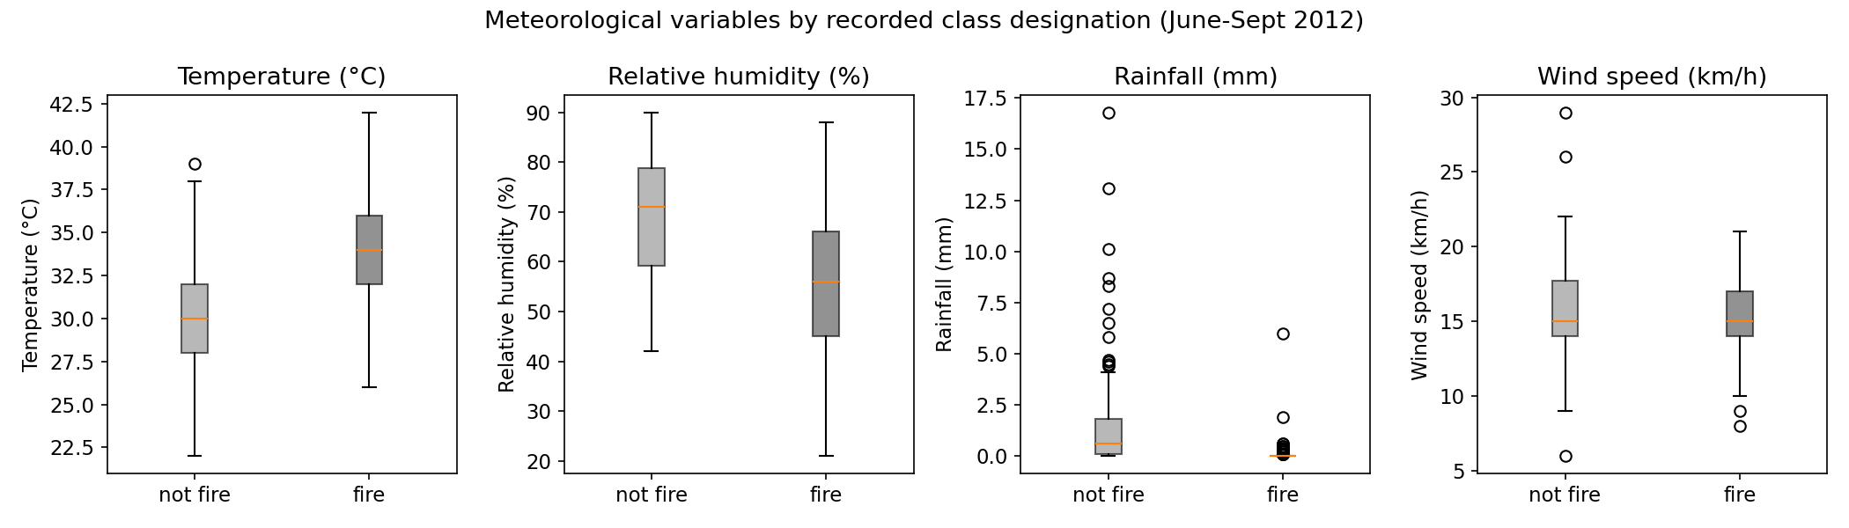
Figure B. Temperature, relative humidity, rainfall and wind speed by recorded class designation.
Monthly proportions varied by region and season (Figure C). Both regions were highest in August (Bejaia 24/31; Sidi-Bel Abbes 27/31), while September fell to 7/30 and 16/30 respectively. These proportions are descriptive and are not fire-occurrence rates.
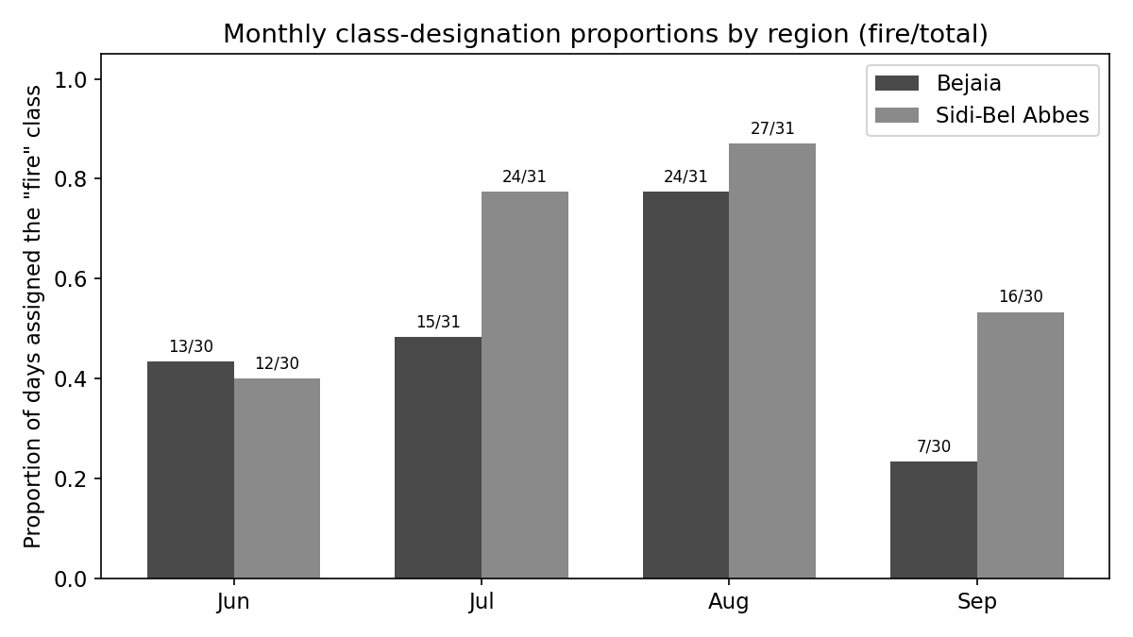
Figure C. Monthly proportions assigned the fire class in each region.
Weekly mean FWI rose to a shared late-August peak before falling sharply (Figure D). A zero-rain run preceded and continued through that peak, but similar dry runs elsewhere did not produce a comparable peak; therefore, no causal conclusion is justified. The first weekly aggregate was partial.
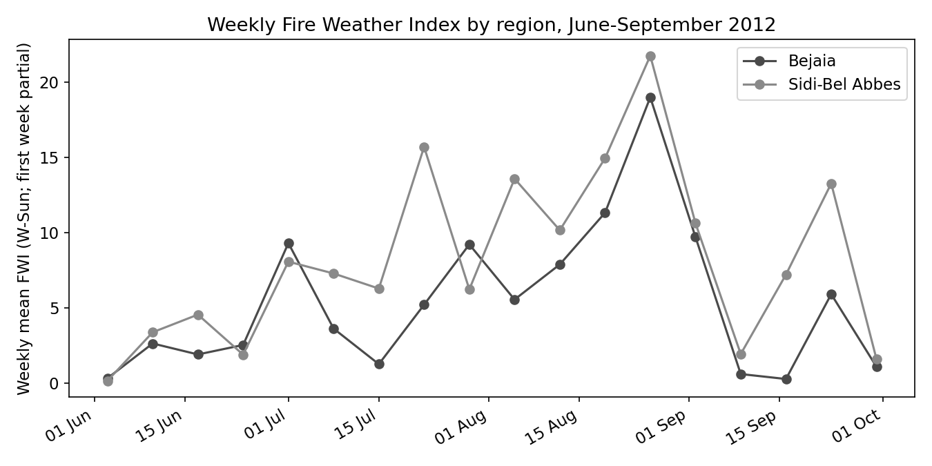
Figure D. Weekly mean FWI by region; the first week is partial.
The EDA therefore supported class-aware evaluation, temporal validation, regional adjustment and sensitivity checks. Registered model candidates were not selected after viewing their outcomes.
- Describe the cleaning/fixing you did on the data, and why (300 words)
Data cleaning and preparation
The raw CSV was not a single rectangular table: it contained two regional blocks, region-title rows, repeated embedded headers, blank separators, surrounding whitespace and one row with a missing comma that merged two numeric fields. The cleaning pipeline read and verified the file’s own 14-column headers, skipped structural rows, separated the blocks and added Region to preserve Bejaia and Sidi-Bel Abbes membership.
Whitespace was stripped from fields, numeric columns were coerced to appropriate integer or floating-point types, and class labels were standardised to fire and not fire. The day, month and year fields were combined into a calendar date. These transformations standardised representation without redefining the recorded measurements or the FWI/FFMC-derived target designation.
The malformed Sidi-Bel Abbes record dated 14 July 2012 was reconstructed using the most plausible field split, DC = 14.6 and ISI = 9. Because the missing comma cannot be recovered with certainty, the row was retained and explicitly marked record_repaired=True; all other rows were marked False.
Validation confirmed schema and analytical consistency: 244 records, 17 attributes, no missing values, no duplicate rows, exactly two regions with 122 records each, two standardised class labels, and dates restricted to 1 June–30 September 2012. The final attributes comprise the 14 original fields plus Region, date and record_repaired.
Reproducibility is supported by the frozen command-line cleaning script, cleaned CSV, Phase 2 documentation, manifest and SHA-256 checksums. These records identify the input, transformations, validation rules and authoritative output. Cleaning resolved structural and formatting defects but could not verify the reconstructed comma, improve source representativeness, or independently validate how the target class was created.
- Explain what analysis techniques and evaluation criteria you used to answer your business/research questions and for evaluating the performance of the analysis techniques, and why (300 words maximum)
Analytical techniques and evaluation criteria
RQ1 evaluated reproduction of the recorded class designation through four grouped leave-one-month-out folds, holding out June, July, August and September in turn. This preserved temporal grouping instead of randomly mixing observations (Roberts et al., 2017). Preprocessing was learned from each training fold only. A fold-trained majority baseline was compared with preregistered unpenalised logistic regression, a shallow decision tree and a fixed random forest. Logistic regression supports interpretable binary-response associations, while trees represent nonlinear partitions and random forests aggregate randomised trees (Hosmer, Lemeshow and Sturdivant, 2013; Breiman et al., 1984; Breiman, 2001). Random cross-validation, tuning and threshold optimisation were prohibited.
Balanced accuracy was primary because monthly class proportions varied and it weights class-specific performance equally (Brodersen et al., 2010). Secondary metrics were accuracy, fire precision, fire recall, fire F1, not-fire recall, ROC-AUC, average precision and confusion counts. Metrics were recorded for each held-out month, as an unweighted four-fold mean with sample SD, and as pooled out-of-fold summaries. Candidates had to exceed the fold-mean baseline; mean balanced accuracy, 0.005 practical tie, SD and fixed interpretability order set preference. Rain_any and the three-day boundary-gap analysis were sensitivity checks excluded from model selection. Standardised logistic coefficients/odds ratios and held-out random-forest permutation importance were non-causal; importance was model-dependent (scikit-learn developers, n.d.).
RQ2 combined an unadjusted region–class contingency analysis with R0 (region only), R1 (Temperature/RH adjusted), R2 (all four weather variables adjusted) and exploratory R3 (Region × Rain). Model-based odds ratios, ordinary model-based 95% confidence intervals and AIC described specifications; a likelihood-ratio test compared R2 with R3. Inference remains specification-dependent and non-causal.
RQ3 used regional monthly class proportions and weekly mean FWI descriptively, without forecasting or causal modelling. Mann–Whitney tests and numerical Cliff’s δ supported exploratory comparisons where distributions were skewed or outlier-prone, but did not remove temporal-dependence concerns.
- Summarise the results of your analysis. What do the results say in answer to your business/research questions? (300 words maximum)
Results and conclusions
RQ1. Random forest was selected among the registered primary candidates for reproducing the FWI/FFMC-derived class designation. Mean leave-one-month-out balanced accuracy was 0.853 (SD 0.049), with pooled out-of-fold balanced accuracy 0.867; the decision tree (0.838) and logistic model (0.742) were lower under the registered primary comparison (Figure 4). The preregistered Rain_any logistic sensitivity reached 0.857 but was excluded from model selection; with only four folds and a difference of about 0.004, this does not demonstrate reliable superiority.
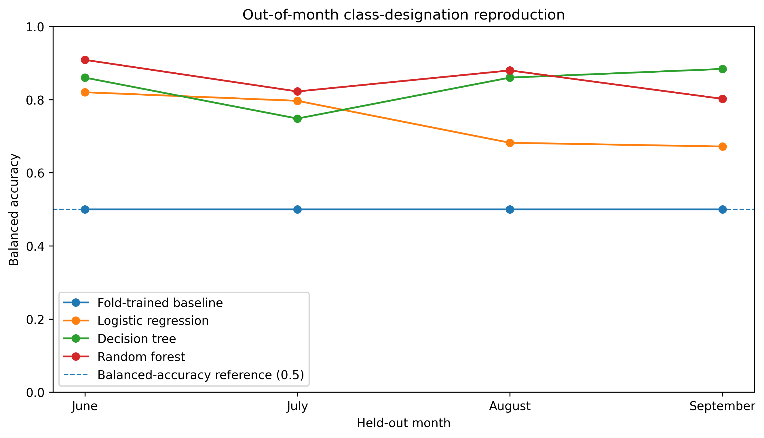
Figure 4. Leave-one-month-out balanced accuracy.
Held-out random-forest permutation importance identified Rain as dominant (0.277 balanced-accuracy decrease), followed by RH (0.033), Temperature (0.025) and wind speed (−0.006). Standardised logistic odds ratios were Temperature 3.046, RH 0.517, wind speed 1.351 and Rain 0.007 (Figure 5). Rain’s coefficient was sensitive to sparse influential observations and is neither a stable physical effect nor causal.
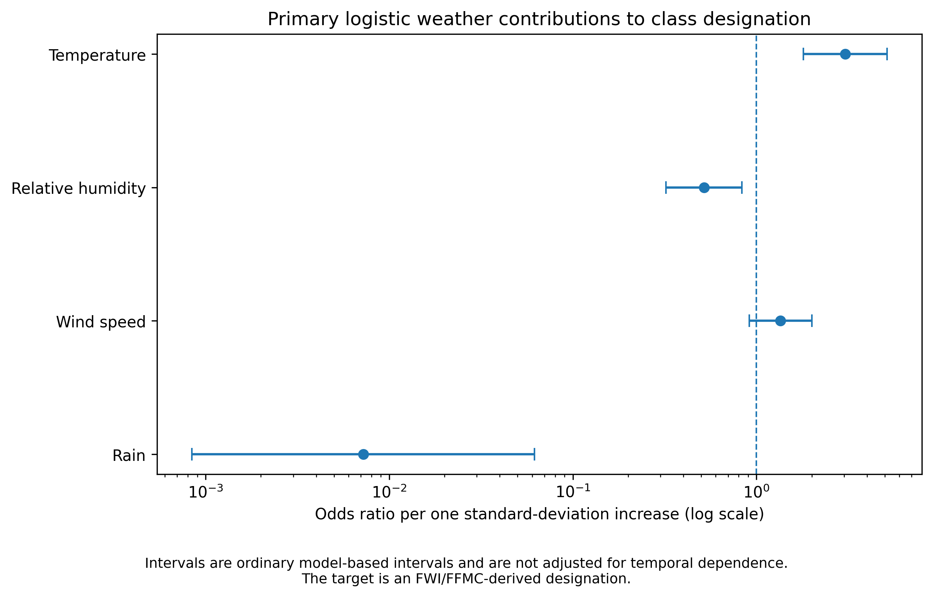
Figure 5. Standardised logistic odds ratios.
RQ2. Region was associated with designation in R0 (OR 1.962; 95% CI 1.173–3.280), became approximately null after Temperature/RH adjustment in R1 (OR 0.995), and was uncertain in R2 (OR 1.724; 95% CI 0.830–3.577). Thus, regional association did not persist robustly across weather-adjusted specifications. Exploratory R3 produced extreme, unstable Region × Rain estimates from sparse, near-separating rainfall patterns and should not be treated as precise effects.
RQ3. Figures C and D showed that both regions had their highest fire-designation proportions in August, with lower September proportions. Weekly mean FWI shared a late-August peak followed by decline. These are descriptive designation and FWI patterns, not independently observed fire-occurrence rates or forecasts.
Further work should assess generalisability across additional seasons and regions, using independently observed wildfire outcomes.

Section 2 — Dealing with large data sets.
- Imagine that you have to deal with a much larger version of this dataset, with gigabytes of data already held and tens of megabytes of new data arriving each day. Assume that rapid response to new data is required e.g. certain messages being sent immediately as soon as certain automated analysis results produce results of a certain value (e.g. a count of items of a particular type exceeds a predetermined threshold). Describe a way that you could use appropriate technologies to spread the load over multiple computers and justify why this would be a good approach. (300 words maximum)
Proposed scalable big-data architecture
The current dataset contains only 244 records. Therefore, this is a hypothetical extension for much larger historical, sensor, weather and regional datasets; it was not implemented, deployed, benchmarked or performance-tested, so no measured speed, cost, throughput, latency or reliability is claimed.
Continuous weather-station and sensor events would enter partitioned Apache Kafka topics, while controlled batch loaders would ingest historical files and external weather data (Apache Software Foundation, n.d.-a). Both paths would write to HDFS or equivalent distributed storage, separating immutable raw, validated and curated zones. Retaining raw inputs and versioned schemas would preserve traceability, while distributed blocks and replication would support larger retained datasets and recovery from node failure (Apache Software Foundation, n.d.-b).
Apache Spark workers would perform distributed cleaning, aggregation, feature preparation and model execution. Schema and data-quality checks would prevent release to the curated zone until validation passed. Spark streaming jobs could evaluate threshold rules and trigger messages, while scheduled batch work would remain separate (Apache Software Foundation, n.d.-c). Apache Airflow DAGs would coordinate ingestion, validation, transformation, modelling and reporting, recording dependencies, retries and execution logs; Airflow would not form the immediate alert path (Apache Software Foundation, n.d.-d).
Containerised analytical services would run across Kubernetes worker nodes and scale horizontally as demand increased, subject to configured metrics (Kubernetes Authors, 2026). Prometheus-style metrics and alerts would track failures, resource use, freshness and service health; data and model-drift monitoring would be a future control, not a completed project feature (Prometheus Authors, n.d.).
Managed secrets encrypted at rest and role-based access would protect credentials (Kubernetes Authors, 2025; Kubernetes Authors, n.d.). Encryption in transit, data minimisation, retention rules, and versioned code, models and logs support governance and reproducibility. This design offers parallelism and traceability beyond a single machine, but adds infrastructure cost, operational complexity and specialist skill requirements.

Section 3 — Privacy
- Imagine that this data will be used in support of a public-facing application. List the three most salient privacy issues related to this analysis and give strategies you could use to address each of them. (300 words maximum)
Privacy issues, legislation and mitigations
The current 244-record public analytical dataset contains no direct personal identifiers. Privacy risks would arise only if a future UK public-facing platform processed personal data such as precise locations, account or device identifiers, alert subscriptions or usage histories. The relevant framework would be the UK GDPR and Data Protection Act 2018, as amended by the Data (Use and Access) Act 2025 (Information Commissioner’s Office, 2026).
1. Data minimisation. Collecting precise coordinates or persistent identifiers alongside weather observations could reveal routines and exceed the platform’s defined purpose. UK GDPR Article 5(1)(c) requires personal data to be adequate, relevant and limited to what is necessary (Information Commissioner’s Office, n.d.-a). The platform should default to coarse regions, restrict schemas to justified fields, make precise location optional and purpose-bound, and separate identity from pseudonymised analytical records. These controls reduce unnecessary collection and linkage.
2. Storage limitation. Replicated raw stores, backups and logs could retain identifiable location or user histories after their operational value ends. Article 5(1)(e) requires identifiable personal data to be kept no longer than necessary (Information Commissioner’s Office, n.d.-b). Field-specific retention schedules, automated deletion or anonymisation, backup lifecycle rules, documented exceptions and periodic reviews would remove or de-identify expired records and provide evidence of retention control.
3. Integrity, confidentiality and security. Distributed ingestion, storage, processing and deployment services create risks of unauthorised access, disclosure, alteration or loss. Article 5(1)(f) and Article 32 require security measures appropriate to processing risk (Information Commissioner’s Office, 2023). Encryption in transit and at rest, authentication, administrator MFA, RBAC and least privilege, managed secrets, access logging, patching, tested backups and incident-response procedures would reduce compromise and support recovery. These measures lower risk but do not guarantee compliance or prevent every breach.

Section 4 — Report references
- Provide a correctly structured list of references to all the resources used for this development and report (no word limit)
Abid, F. (2019) Algerian Forest Fires [Dataset]. Irvine, CA: UCI Machine Learning Repository. Available at: https://doi.org/10.24432/C5KW4N (Accessed: 1 August 2026).
Abid, F. and Izeboudjen, N. (2020) ‘Predicting Forest Fire in Algeria Using Data Mining Techniques: Case Study of the Decision Tree Algorithm’, in Ezziyyani, M. (ed.) Advanced Intelligent Systems for Sustainable Development (AI2SD’2019), Advances in Intelligent Systems and Computing, 1105, pp. 363–370. Cham: Springer. Available at: https://doi.org/10.1007/978-3-030-36674-2_37 (Accessed: 1 August 2026).
Apache Software Foundation (n.d.-a) ‘Introduction’, Apache Kafka documentation. Available at: https://kafka.apache.org/documentation/ (Accessed: 1 August 2026).
Apache Software Foundation (n.d.-b) ‘HDFS Architecture’, Apache Hadoop 3.3.5 documentation. Available at: https://hadoop.apache.org/docs/stable/hadoop-project-dist/hadoop-hdfs/HdfsDesign.html (Accessed: 1 August 2026).
Apache Software Foundation (n.d.-c) ‘Structured Streaming Programming Guide’, Apache Spark 4.2.0 documentation. Available at: https://spark.apache.org/docs/latest/streaming/index.html (Accessed: 1 August 2026).
Apache Software Foundation (n.d.-d) ‘Architecture Overview’, Apache Airflow 3.3.0 documentation. Available at: https://airflow.apache.org/docs/apache-airflow/stable/core-concepts/overview.html (Accessed: 1 August 2026).
Breiman, L. (2001) ‘Random Forests’, Machine Learning, 45(1), pp. 5–32. Available at: https://doi.org/10.1023/A:1010933404324 (Accessed: 1 August 2026).
Breiman, L., Friedman, J.H., Olshen, R.A. and Stone, C.J. (1984) Classification and Regression Trees. Monterey, CA: Wadsworth & Brooks/Cole Advanced Books & Software. Available at: https://search.worldcat.org/title/9970700 (Accessed: 1 August 2026).
Brodersen, K.H., Ong, C.S., Stephan, K.E. and Buhmann, J.M. (2010) ‘The Balanced Accuracy and Its Posterior Distribution’, in 2010 20th International Conference on Pattern Recognition, pp. 3121–3124. IEEE. Available at: https://doi.org/10.1109/ICPR.2010.764 (Accessed: 1 August 2026).
Hosmer, D.W., Lemeshow, S. and Sturdivant, R.X. (2013) Applied Logistic Regression. 3rd edn. Hoboken, NJ: Wiley. Available at: https://doi.org/10.1002/9781118548387 (Accessed: 1 August 2026).
Information Commissioner’s Office (2023) ‘A guide to data security’, updated 19 May 2023. Available at: https://ico.org.uk/for-organisations/uk-gdpr-guidance-and-resources/security/a-guide-to-data-security/ (Accessed: 1 August 2026).
Information Commissioner’s Office (2026) ‘The Data Use and Access Act 2025 (DUAA): what does it mean for organisations?’, updated 19 June 2026. Available at: https://ico.org.uk/about-the-ico/what-we-do/legislation-we-cover/data-use-and-access-act-2025/the-data-use-and-access-act-2025-what-does-it-mean-for-organisations/ (Accessed: 1 August 2026).
Information Commissioner’s Office (n.d.-a) ‘Principle (c): Data minimisation’. Available at: https://ico.org.uk/for-organisations/uk-gdpr-guidance-and-resources/data-protection-principles/a-guide-to-the-data-protection-principles/data-minimisation/ (Accessed: 1 August 2026).
Information Commissioner’s Office (n.d.-b) ‘Principle (e): Storage limitation’. Available at: https://ico.org.uk/for-organisations/uk-gdpr-guidance-and-resources/data-protection-principles/a-guide-to-the-data-protection-principles/storage-limitation/ (Accessed: 1 August 2026).
Kubernetes Authors (2025) ‘Good practices for Kubernetes Secrets’, Kubernetes documentation. Available at: https://kubernetes.io/docs/concepts/security/secrets-good-practices/ (Accessed: 1 August 2026).
Kubernetes Authors (2026) ‘Kubernetes overview’, Kubernetes documentation. Available at: https://kubernetes.io/docs/concepts/overview/ (Accessed: 1 August 2026).
Kubernetes Authors (n.d.) ‘Using RBAC Authorization’, Kubernetes documentation. Available at: https://kubernetes.io/docs/reference/access-authn-authz/rbac/ (Accessed: 1 August 2026).
Prometheus Authors (n.d.) ‘Overview’, Prometheus documentation. Available at: https://prometheus.io/docs/introduction/overview/ (Accessed: 1 August 2026).
Roberts, D.R., Bahn, V., Ciuti, S., Boyce, M.S., Elith, J., Guillera-Arroita, G., Hauenstein, S., Lahoz-Monfort, J.J., Schröder, B., Thuiller, W., Warton, D.I., Wintle, B.A., Hartig, F. and Dormann, C.F. (2017) ‘Cross-validation strategies for data with temporal, spatial, hierarchical, or phylogenetic structure’, Ecography, 40(8), pp. 913–929. Available at: https://doi.org/10.1111/ecog.02881 (Accessed: 1 August 2026).
scikit-learn developers (n.d.) ‘Permutation feature importance’, scikit-learn 1.9.0 documentation. Available at: https://scikit-learn.org/stable/modules/permutation_importance.html (Accessed: 1 August 2026).

